**Registers pertaining to MIPS Architecture**

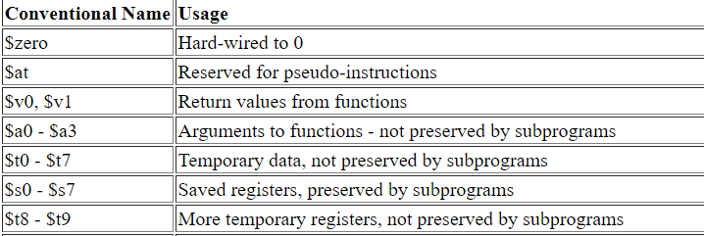

Any register, for example is t1. If $ is present as $ t1-it indicates the content within the register t1.

t-indicates temporary registers, whereas s indicates saved registers.

Zero -register is a register with content 0.

a0-a3: arguments to passed to functions and returns values from functions indicated by v0 and v1

